Unit 5 : Exploring the Mysteries

Lesson 19: Jungles and Rainforests

1. Match each word to its definition.

Appreciate Provide with the food or other substances

necessary for growth

Nourish Change the form

Cool Slightly wet

Pounce Move smoothly or slide

Slither Flow rapidly in a steady stream

Damp Make a sudden approach

Pour Recognize the full worth of

Convert Noticeably cold

Word Bank

|  |
| --- |
| How down allow show row drown growl bow cow now throw crowd know |

Fill in the table.

|  |  |
| --- | --- |
| Words that rhyme with “ crow” | Words that rhyme with “owl” |
|  |  |
|  |  |
|  |  |
|  |  |
|  |  |

Choose 1 word that rhyme with “owl” and use it in a sentence.

______________________________________________________________________

Choose 1 word that rhyme with ‘’crow’’ and use it in a sentence.

_______________________________________________________________________

Look at each picture then write a sentence under each picture to describe how the character feels.

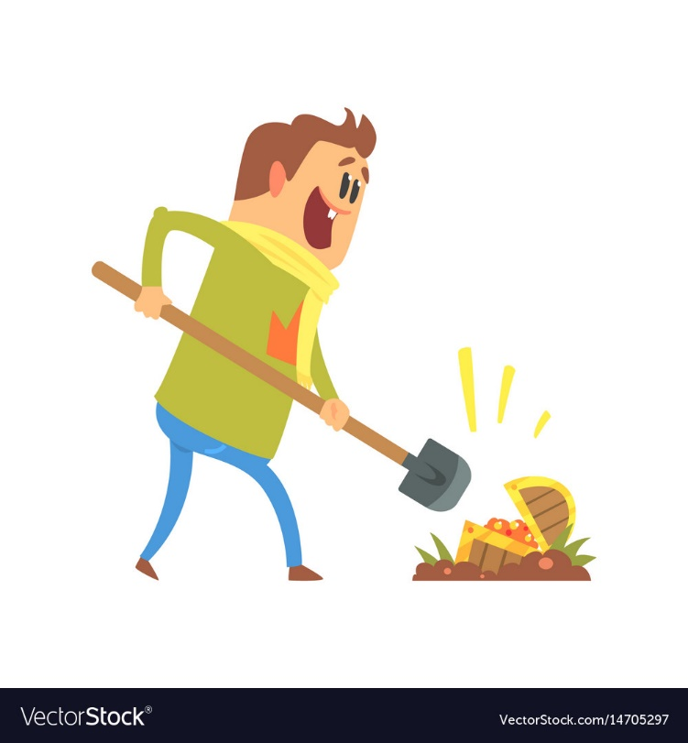

______________________________________________________________________

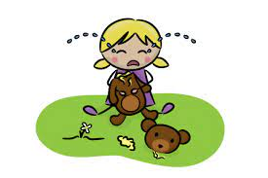

_______________________________________________________________________

Correct the underlined grammatical error in each sentence.

Rewrite the sentences.

1. He walked **slow** back to his room.

___________________________________________________________________

1. The storm passed **slow** .

___________________________________________________________________

1. She choose her words **careful.**

___________________________________________________________________

1. I got a **painfully** sunburn.

___________________________________________________________________

1. It is **nosily** next doors.

___________________________________________________________________